# Department of Computing

**CS-344: Web Engineering**

**Class:** BESE-11AB

# Lab 02: HTML Basics

**Date: 22.09.22**

**Tanzeel Ur Rehman**

**345510**

# Instructor: Dr. Qaiser Riaz

# 

# Lab 02: HTML Basics

### Introduction:

HTML is the standard markup language for creating web pages and web applications. During lectures, students have learned the structure of an HTML document and basic HTML tags. In this lab, students will practice the basic HTML tags.

### Lab Objectives:

The objective of this lab is to help students in building a single page website using basic HTML tags. Students will apply the basic HTML tags such as tables, links, lists etc. to create single page web site.

### Tools:

Dreamweaver, notepad, browser.

### Helping Material:

W3Schools: <https://www.w3schools.com/html/default.asp>

HTML Links: <https://www.w3schools.com/html/html_links.asp>

HTML Lists: <https://www.w3schools.com/html/html_lists.asp>

HTML Tables: <https://www.w3schools.com/html/html_tables.asp>

### Lab Task

### Task 1

Lists are important tags to display text in a list format. Get yourself familiarized with the basic concepts of lists (link is given above) and create an HTML page similar to the one given below:

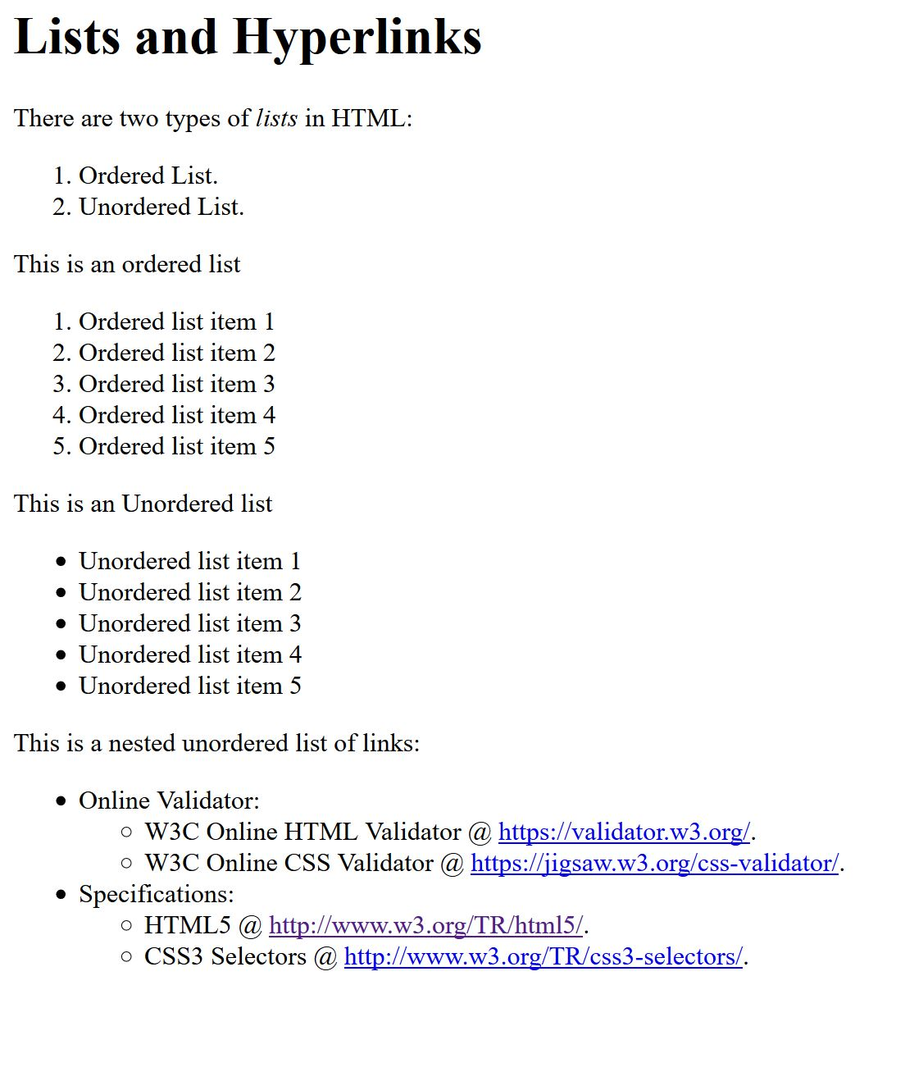

### Task 2

In HTML, it is possible to display text in tables and for this purpose <table> tag is used. Get yourself familiarized with the basic concepts of tables (link is given above) and create an HTML page showing an invoice in tabular format. An example is given below. Feel free to add/extend it for hands-on:

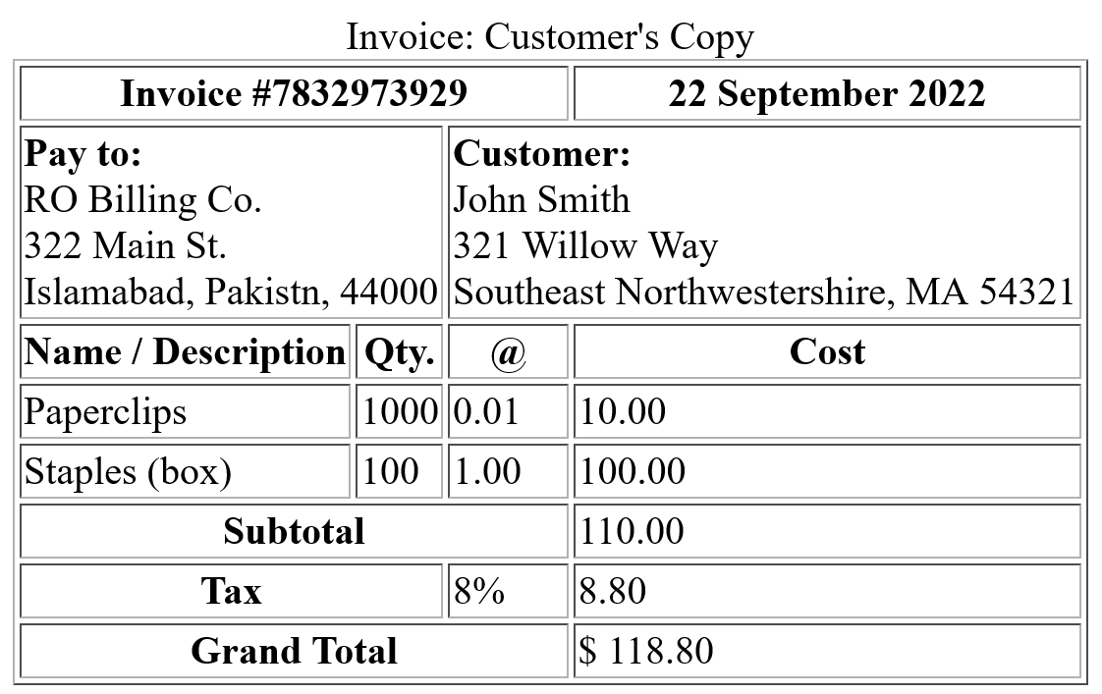

|  |
| --- |
| Solution |
| Screenshot of all HTML pages (Task 1, Task 2)      HTML Code: Task 1  <!DOCTYPE html>  <html lang="en">  <head>      <meta charset="UTF-8">      <meta http-equiv="X-UA-Compatible" content="IE=edge">      <meta name="viewport" content="width=device-width, initial-scale=1.0">      <title>Lists and Hyperlinks</title>  </head>  <body>      <h1>Lists and Hyperlinks</h1>      <p>There are two types of lists in HTML:</p>        <ol>          <li>Ordered List.</li>          <li>Unordered List.</li>      </ol>      <p>This is an ordered list</p>        <ol>          <li>Ordered list item 1</li>          <li>Ordered list item 2</li>          <li>Ordered list item 3</li>          <li>Ordered list item 4</li>          <li>Ordered list item 5</li>      </ol>        <p>This is an Unordered list</p>      <ul>          <li>Unordered list item 1</li>          <li>Unordered list item 2</li>          <li>Unordered list item 3</li>          <li>Unordered list item 4</li>          <li>Unordered list item 5</li>      </ul>        <p>This is a nested unordered list of links:</p>        <ul>          <li>Online Validator:              <ul>                  <li>                      W3C Online HTML Validator @ <a href="https://validator.w3.org/">https://validator.w3.org/.</a>                      W3C Online CSS Validator @ <a href="https://jigsaw.w3.org/css-validator/">https://jigsaw.w3.org/css-validator/.</a>                  </li>              </ul>          </li>          <li>              Specificatons:              <ul>                  <li>HTML5 @ <a href="http://www.w3.org/TR/html5/">http://www.w3.org/TR/html5/</a></li>                  <li>CSS3 Selectors @ <a href="http://www.w3.org/TR/css3-selectors/">http://www.w3.org/TR/css3-selectors/</a></li>              </ul>          </li>      </ul>  </body>  </html>  HTML Code: Task 2  <!DOCTYPE html>  <html lang="en">    <head>      <meta charset="UTF-8" />      <meta http-equiv="X-UA-Compatible" content="IE=edge" />      <meta name="viewport" content="width=device-width, initial-scale=1.0" />      <title>Table</title>    </head>    <body>      <table border="2" width="60%" align="center">        <caption align="above">          <b> Invoice: Customer's Copy</b>        </caption>        <tr>          <th colspan="5" align="center">Invoice #7832973929</th>          <th colspan="5" align="center">22 September 2022</th>        </tr>        <tr>          <td colspan="4">            <b> Pay to:</b><br />            RO Billing Co. <br />322 Main St. <br />Islamabad, Pakistan, 44000          </td>          <td colspan="6">            <b> Customer: </b> <br />            John Smith Customer: <br />            321 Willow Way <br />            Southeast Nortwestershire, MA 54321          </td>        </tr>        <tr>          <td colspan="3">            <b>Name / Description</b>          </td>          <td>            <b>Qty.</b>          </td>          <td><b>@</b></td>          <td colspan="5" align="center">            <b>Cost</b>          </td>        </tr>        <tr>          <td colspan="3">Parperclips</td>          <td>1000</td>          <td>0.01</td>          <td colspan="5">10.00</td>        </tr>        <tr>          <td colspan="3">Staples (box)</td>          <td>100</td>          <td>1.00</td>          <td colspan="5">100.00</td>        </tr>        <tr>          <td colspan="5" align="center"><b>Subtotal</b></td>          <td colspan="5">110.00</td>        </tr>        <tr>          <td colspan="4" align="center"><b>Tax</b></td>          <td colspan="1">8%</td>          <td colspan="5">8.80</td>        </tr>        <tr>          <td colspan="5" align="center"><b>Grand Total</b></td>          <td colspan="5">$ 118.80</td>        </tr>      </table>    </body>  </html> |

### Deliverables

Compile a single word document by filling in the solution part and submit this Word file with code files on LMS. You must include your name, ID, and class on first page. The lab grading policy is as follows: The lab is graded between 0 to 10 marks. For some of the labs, students have to present their solutions in a viva session. In case of any problems with submissions on LMS, you should contact your lab engineer Ms. Ayesha Asif by email at [ayesha.asif@seecs.edu.pk](mailto:ayesha.asif@seecs.edu.pk) .